Rm 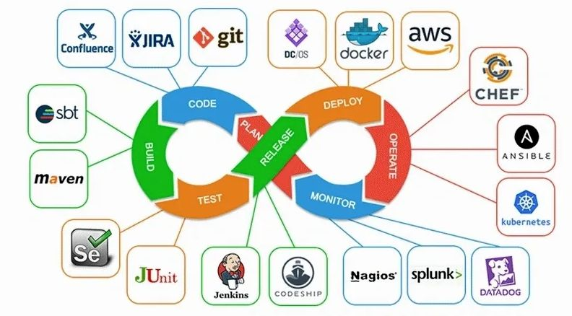

**Versioning strategy:**

**Ex: version = 1.1.0**

**Note: 1 = major version**

**0 = minor version**

**2 = Patch version**

**Software Teams :**

**Developers team**

**DevOps Team**

**QA team (testing)**

**UAT team (user acceptance testing)**

**Pre-production or Staging**

**Production team**

git will be used in local system.

github is used to store the data from deve.

Touch command is used to create a file .

ls command is used to view list of file.

Ls –al command is used to view the hidden the files

Clear command is used to clear screen (empty the screen) also (ctrl+l) command is also used to clear the screen

vi or vim command is used to store the data and edit the file.

esc+ :wq used to save file.( ‘w’ is abbreviated as save and ‘q’ is abbreviated as quit)

rm file_name.txt command is used to delete the file.

mkdir naseer command Is used to create a directory(folder)

cd .. command is used to change the directory(folder)

rmdir naseer command used to delete the directory(folder)

cat (file name) command is used to view the content of the file

How to install the gitbash:

<https://github.com/git-for-windows/git/releases/download/v2.30.1.windows.1/Git-2.30.1-64-bit.exe>

git hub command:

repository: means storage

git init (used to Initialized empty Git repository)

git clone url (used to clone the git hub repo to local system)

git add . (adding the files to github repo)

git commit –m “add the commit” (* means changes has been done on code)

git push -origin master (to push the data to github)

git remote add origin “github repo url”

(first create a file > now create the new github repo > find the “code” under copy the git hub repo url > now go to git bash > run command “git init” > to clone the git hub repo to local system run the command “git clone url ” > now the add the file to repo run command “git add .” > Now add the commit run command: git commit –m “add the commit” > git remote add origin “git hub url” > all the data has been added to git hub repo now push the data to repo git repo, to push data to repo run command: git push origin master)

mkdir (nasir)

git clone (url)

ls (list of files)

cd (ex: name of the repo (folder) that which I’ve created in git hub)

touch (file)

vim ( to add or store the content)

git add .

git commit –m “add the commit” ( like it’s a scheduled work)

git push

To create a master branch:

Git checkout –b “master”

Touch (file)

Vim

Git add .

Git commit –m “add the commit”

Git remote add origin ‘url’

Git push origin master